**Q3. (i) What is meant by requirement engineering? Describe some of the problems or issues in this activity when it is a part of the Waterfall lifecycle.**

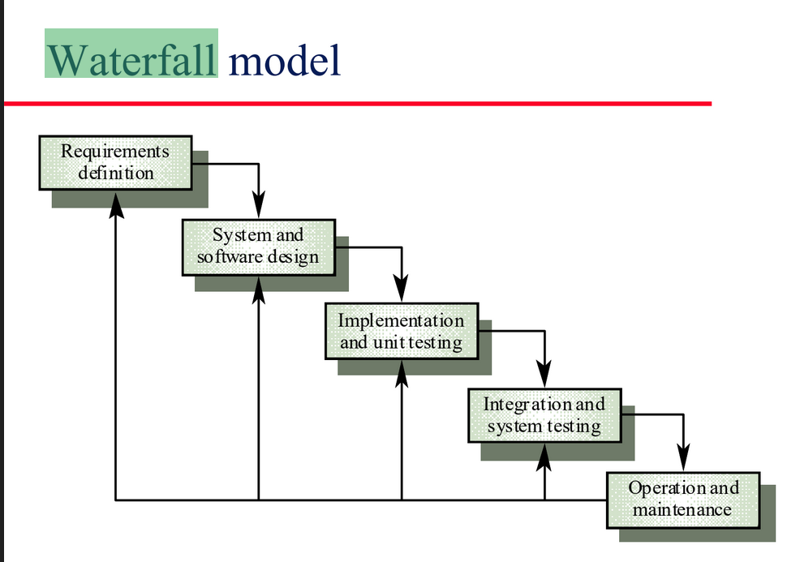

Requirement engineering :

* This refers to the requirement gathering and analysis aspect of software development
* In terms of the waterfall cycle this refers to the first stage requirements stage which is commonly split in to Requirements Gathering and Requirements Analysis or just Requirements Definition as a whole.

Cons of this stage when used in the waterfall cycle :

* The waterfall is a fixed documentation first development next development model. If the requirements aren’t complete or correct the whole waterfall model has to be restarted to the beginning.
* This also means that whatever non fatal problems arise mid development may fail to be fully addressed due to the lack of flexibility in the waterfall cycle.

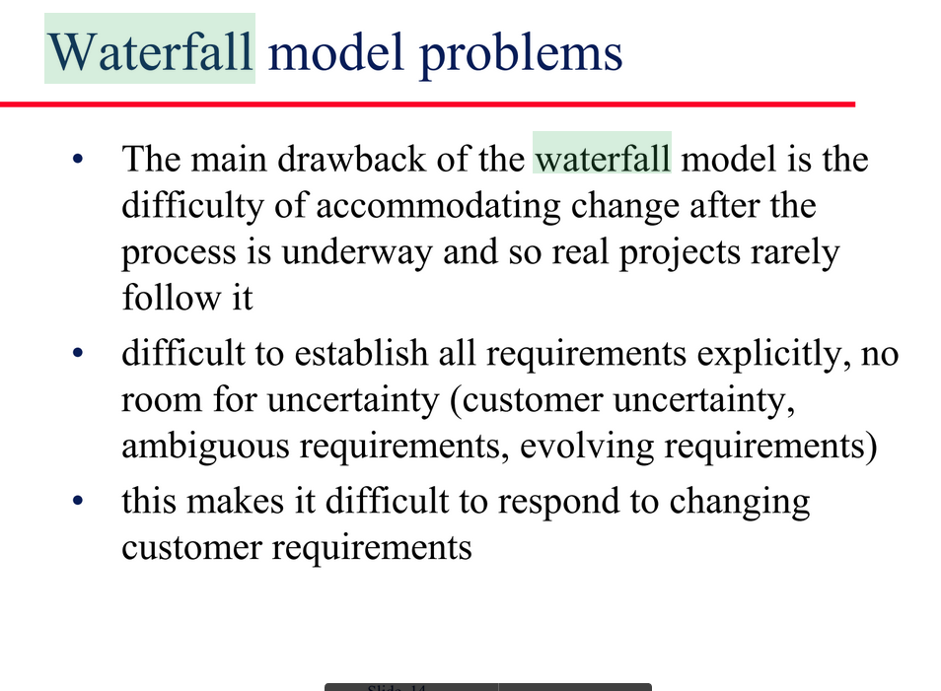

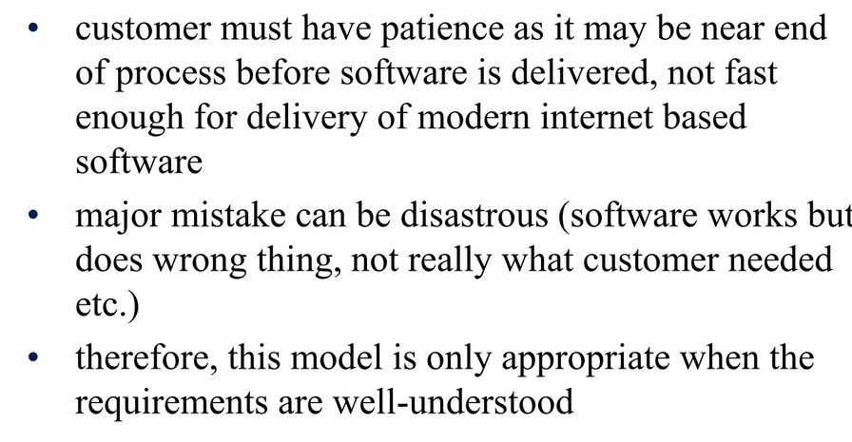

**(ii) Describe the four processes of the unified process (UP) paying particular attention to the Elaboration and Construction phases.**

Inception :

Establishing business rationale, deciding project scope, get commitment from sponsor to proceed further. This ranges from a few hours chat to a spreadsheet plan of serious feasibility study over a couple of months.

Elaboration :

Collecting more detailed requirements, do high level analysis and design, establish baseline architecture, project planning.

* This is essentially requirements analysis in the sense that this is the refining of the initial requirements after the project has been greenlit.

Construction :

Key phase for iteration which can be in any phase, each iteration builds production-quality software which is tested and integrated, which satisfies a subset of project requirements

* This is essentially the main development phase, it’s not linear like waterfall and what defines unified process to be an agile development method/ spiral model where development is done in iterations satisfying a few requirements at a time modularly.

Transition : This phase involves beta testing, performance tuning, user training, user documentation.

